Project Title
Machine Learning for Mental State Recognition from a Wearable EEG Device

Table of Contents
1. Mental state problem definition 3
Focus 3
Relaxation 3
2. Feature selection and analysis 4
2.1 Feature Selections 5
• Window data and overlaping 5
2.2 Feature Analysis 6
3. Specific Objectives 7
4. Implementation Methodology 8
Phase 1: Building the Foundation Model (Weeks 1-4) 8
Phase 2: New Data Collection with Muse 2 (Weeks 5-7) 8
1. Introduction and Guidelines (3 minutes) 9
2. Consent Form Signing (2 minutes) 9
3. Setup (2 minutes) 9
4. Experimental Conditions 9
5. Questionnaires (5 minutes) 9
Phase 3: Model Fine-tuning (Weeks 8-10) 10
Phase 4: Performance Evaluation (Weeks 11-12) 10
Phase 5: Report Writing (Weeks 13-14) 10
References 10

Mental state problem definition
A mental state refers to the cognitive and emotional condition or state of mind of an individual at a given time. It encompasses a wide variety of phenomena including thoughts, feelings, perceptions, intentions, beliefs, desires, and moods. Mental states reflect both internal brain processes and outward behaviors, influenced by a person's interactions with their environment.

Focus
Definition: Focus is the directed, sustained attention toward a specific task or stimulus, accompanied by the active suppression of distractions. Focus is often a transient state that varies with mental effort and task difficulty, and it cannot be maintained indefinitely before fatigue or mind-wandering ensues.

Distinctive Properties: When someone is highly focused, they experience heightened
awareness of the target stimulus and diminished awareness of irrelevant stimuli. Focused concentration is associated with high arousal and significant mental effort. Neuroscientifically, focus engages frontal and parietal attention networks responsible for executive control of attention and working memory. Notably, focused external attention suppresses the brain’s default mode network (DMN) — the self-referential “idle” network active during wakeful rest. Thus, one generally cannot be deeply relaxed and highly focused at the same time, except in special trained situations (e.g. certain meditative practices achieve a calm form of focus).

Example of High focus task: Difficult continuous performance tasks – e.g. an N-back working memory task (2-back or 3-back) or a Stroop test under time pressure. These impose sustained attention, active working memory, and inhibitory control, requiring strong concentration and resulting in high EEG focus indices.
(References: Posner & Petersen, 1990; Corbetta & Shulman, 2002; Gevins et al., 1997;
Pope et al., 1995; Lim et al., 2019)

Relaxation
Definition: Relaxation is a calm state of low arousal characterized by minimal cognitive
effort and a shift toward parasympathetic nervous system dominance (rest-and-digest
physiology). In this state, the individual is awake but mentally at ease, with reduced stress and often an inward or broad attentional focus. For example, quiet wakeful rest or light meditation are relaxation states. Relaxation typically involves the absence of task demands and an automatic mode of control (nothing to actively concentrate on). As a result, the brain’s default mode network (DMN) – associated with self-referential and introspective thought – tends to be active during relaxation. This contrasts with the executive network activation seen in focused states. Relaxation can be seen as the opposite of effortful focus along the arousal dimension (low activation, low effort). It is often accompanied by positive feelings of calm or relief but notably lacks the strong engagement or excitement of the other states.
Distinctive Properties: A relaxed person feels physically and mentally at ease, with low tension. Attention may drift broadly or turn inward (daydreaming or mindfulness), as opposed to being narrowly targeted. There is little voluntary cognitive control engaged. This state is associated with parasympathetic physiological markers such as slower heart rate, higher HRV, and reduced stress hormones. Psychologically, relaxation is restorative – it allows recovery from cognitive effort and reduces anxiety. Skilled relaxation (as in experienced meditators) can also entail a quieting of internal dialogue and self-judgment, akin to a peaceful awareness. Because relaxation involves low cognitive load, it can coexist with certain introspective or imaginative thoughts (unless it is deep meditative relaxation aiming to clear the mind). In everyday terms, relaxation spans from mild unwinding (e.g. sitting comfortably with eyes closed) to deep relaxation techniques (breathing exercises, mindfulness, etc.).
Example of low relaxation (Baseline rest): Quiet sitting, eyes open. The participant sits calmly with minimal stimulation. This provides a low demand resting baseline (some alpha increase, moderate relaxation).

(References: Cahn & Polich, 2006; Davidson et al., 2003; Lagopoulos et al., 2009; Putman et al., 2010)

2. Feature selection and analysis
From the literature, we have some information about EEG characteristic over mental state.
Focused State: This state primarily depends on the following combination:
- High Beta waves: Beta waves are the dominant frequency, associated with alertness, logical thinking, and problem-solving.
- Low Alpha/Theta waves: The presence of Alpha and Theta indicates relaxation or dreaminess, so their suppression is a strong sign of concentration.
Drowsy State: This state is identified when:
- Increased Theta/Alpha waves: Theta waves become more prominent as the body enters a state of deep relaxation, mind-wandering, or meditation.
- Low Beta waves: Active cognitive processes are significantly reduced.
Unfocused State: This is a state of "mind-wandering," characterized by:
- High Alpha waves: Alpha is the dominant wave when the brain is in a relaxed yet awake state, not focused on any specific task (the default mode, daydreaming).
- Moderate Beta/Theta levels: There is no high concentration (low Beta) but also no deep drowsiness (Theta is not excessively high).

2.1 Feature Selections
From the reported literature and our initial inspection of the dataset, our goal is to identify a robust set of features and an appropriate temporal resolution that maximizes classification performance of machine learning models.

Example for feature extraction:
- Preprocessing:
  - DC removal
  - Notch filter at 50 Hz
  - Notch filter at 60 Hz

- Feature extraction: 23 features for each channels
- Band power (5 features):
  - delta: (0.5, 4),
  - theta: (4, 8),
  - alpha: (8, 13),
  - beta: (13, 30),
  - gamma: (30, 50)
- Normalised bandpower (5 features)::
  - delta/ total
  - theta/total
  - alpha/total
  - beta/total
  - gamma/total
- Band power ratio (5 features):
  - theta/alpha
  - heta/beta
  - beta/alpha
  - beta/gamma
  - alpha/gamma
- Statistical features (6 features):
  - Median
  - Mean
  - Std
  - Min
  - Max
  - Mean of absolute value
- z_ratio (1 feature)
  - (slow_power-fast_power)/(slow_power+fast_power)
where ‘slow_power’ is the power at 0.5 - 8 Hz bandwidth and ‘fast_power’ is the power for 8 - 20 Hz bandwidth
- Spectral Entropy is defined to be the Shannon entropy of the power spectral density (PSD) of the data(1 features)
- Window data and overlaping
We apply a sliding window approach to extract features from the EEG signals with the following settings:
  - Window size: 8 seconds
  - Hop size: 1 second (i.e., 7 seconds overlap between consecutive windows)
Each input sample to the model consists of a sequence of 64 seconds, yielding an input shape of 64 × 23 x n (timestamps × features x number of channels).

2.2 Feature Analysis
To evaluate the quality of extracted features, we analyzed their correlation with the ground truth (GT) labels provided in the dataset. This step helps us understand which features are most relevant for distinguishing between different mental states (e.g., Focus vs. Unfocus).
Average correlations (GT): feature vs confident_score
Feature AF3 AF4
0 delta -0.153982 -0.135109
1 theta -0.265072 -0.250597
2 alpha 0.132206 0.114225
3 beta -0.245395 -0.178795
4 gamma -0.245476 -0.203568
5 delta/total -0.180575 -0.215096
6 theta/total 0.003863 -0.138114
7 alpha/total 0.475971 0.421098
8 beta/total 0.198090 0.195150
9 gamma/total 0.140625 0.140273
10 theta/alpha -0.426421 -0.413633
11 theta/beta -0.177647 -0.228528
12 beta/alpha -0.294782 -0.264642
13 beta/gamma 0.165735 0.129977
14 alpha/gamma 0.360478 0.270893
15 Median 0.093655 0.116583
16 Mean 0.065838 0.083856
17 Std -0.202538 -0.171275
18 Min 0.162854 0.120353
19 Max -0.293251 -0.270867
20 Mean_abs -0.125934 -0.109698
21 z_ratio -0.392946 -0.384359
22 Entropy 0.259321 0.221312

Statistical reports: example for 46 features correspond to 23 features per EEG channels (e.g., AF3-T7, AF4-T8):
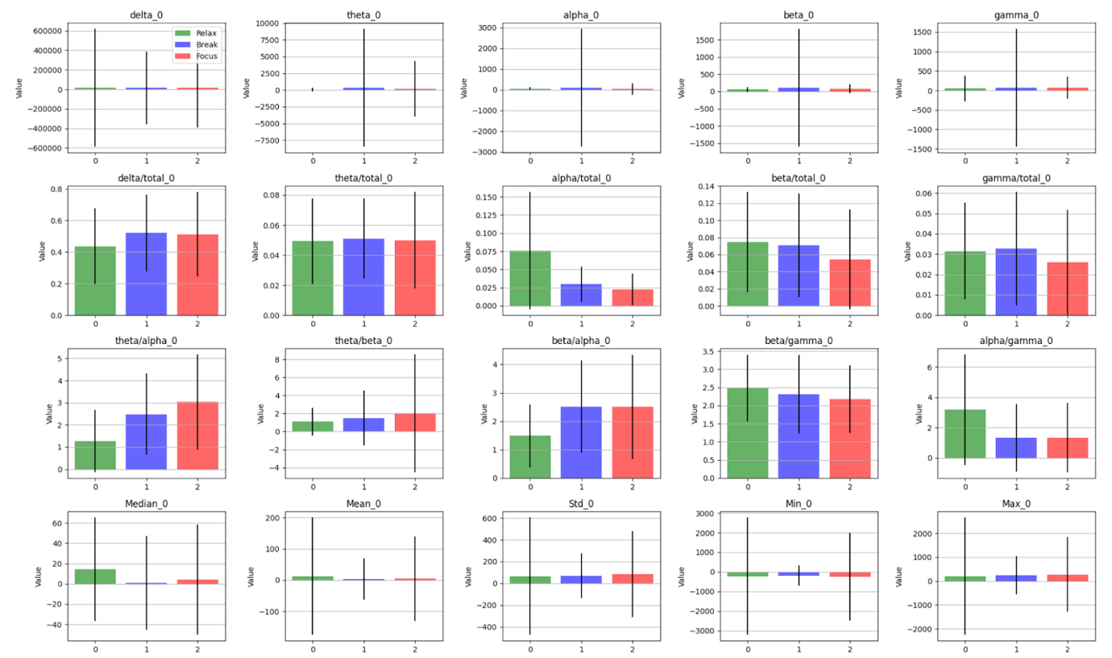
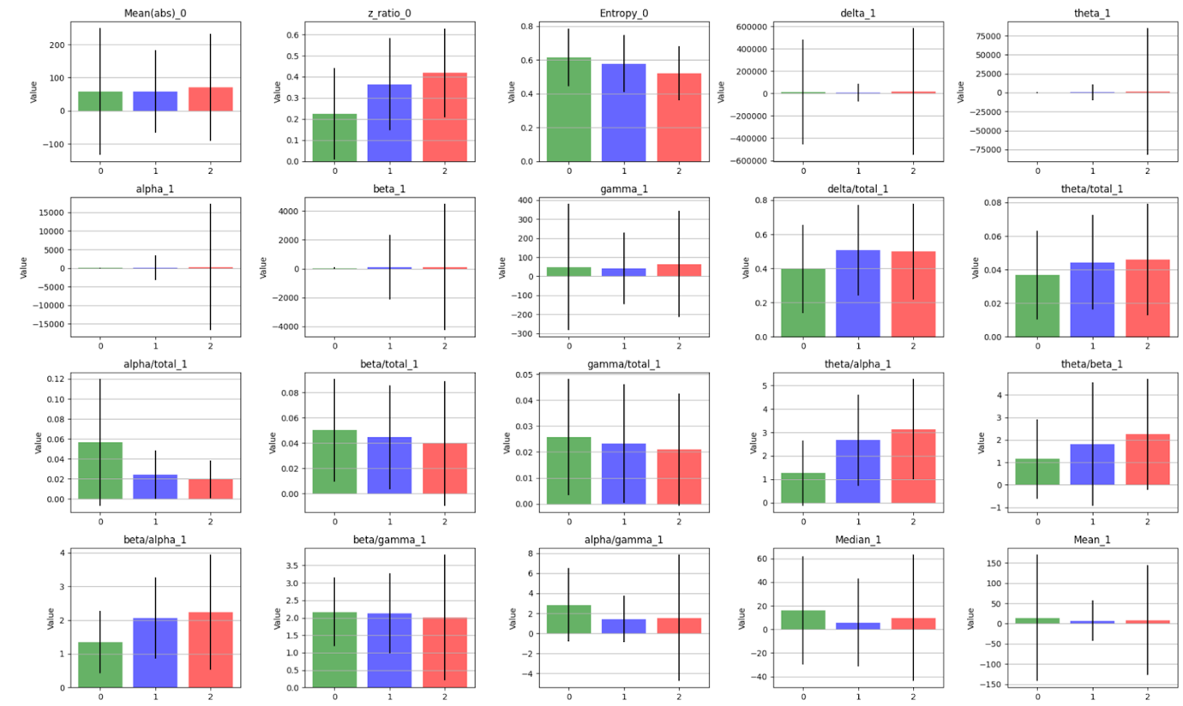

3. Specific Objectives
- Build a Foundation Model: Train a deep learning model capable of accurately classifying 3 core mental states:
  - Focused: An active state of the brain, highly concentrated on a task.
  - Drowsy: A transitional state between wakefulness and sleep, characterized by cognitive decline.
  - Unfocused/Distracted: A state of mind-wandering, not paying attention to a specific task.
- Collect Specialized Data: Use the Muse 2 personal EEG wearable device to build a small, high-quality dataset in a controlled environment.
- Optimize the Model: Apply the Fine-tuning technique to refine the foundation model, helping it adapts and perform effectively with the unique signal characteristics of the Muse 2 device.
- Test and Evaluate: Assess the effectiveness of the fine-tuned model on a new group of users to determine the project's practical applicability.

4. Implementation Methodology

Phase 1: Building the Foundation Model (Weeks 1-4)
- Data: Use a large, publicly available EEG dataset (from Kaggle) to train a model with high generalization capabilities.
- Model Architecture: we propose two types of models for comparison: a neural network model (e.g. Dense Recurrent Neural Network (DRNN)) and a traditional machine learning model (e.g. XGBoost).

We plan to choose the neural network model, since we think it will obtain a better accuracy and it’s convenient for fine-tune the model with new dataset.
Example of a small size DRNN model:
=============================================
Layer (type:depth-idx) Input Shape Output Shape Param #
=============================================
MC_Model_1D [1, 64, 46] [1, 3] --
├─Linear: 1-1 [1, 64, 46] [1, 64, 32] 1,504
├─ELU: 1-2 [1, 64, 32] [1, 64, 32] --
├─Dropout: 1-3 [1, 64, 32] [1, 64, 32] --
├─GRU: 1-4 [1, 64, 32] [1, 64, 16] 2,016
├─Dropout: 1-5 [1, 64, 16] [1, 64, 16] --
├─GRU: 1-6 [1, 64, 16] [1, 64, 8] 528
├─Dropout: 1-7 [1, 64, 8] [1, 64, 8] --
├─Linear: 1-8 [1, 512] [1, 3] 1,539
=============================================
Total params: 5,587
Trainable params: 5,587
Non-trainable params: 0
Total mult-adds (M): 0.17

Phase 2: New Data Collection with Muse 2 (Weeks 5-7)

Proposed Protocol for EEG/fNIRS/PPG Data Collection Using Muse 2 Band

Objective: To collect EEG/fNIRS/PPG data corresponding to three mental states (Drowsy, Unfocus and Focused) using Muse 2 wearable bands for the development and validation of a brain-state recognition system.
Total Duration: ~30 minutes per session
N.o participants: >10
N.o sections: > 100

1. Introduction and Guidelines (3 minutes)
- Brief overview of the study and its purpose.
- Explanation of the procedure and what participants will experience.
- Run N-Back-Game, explain the game, but not start the play game
  - https://github.com/danghoanganh36/N-Back-Game

2. Consent Form Signing (2 minutes)
- Provide and explain the consent form.
- Ensure participant signs before proceeding.

3. Setup (2 minutes)
- Clean electrodes by soft tissues
- Assist the participant with wearing the EEG band.
- Calibrate, check battery status and confirm correct signal acquisition.
- Optional: Set up camera for recording the session (optional).

4. Experimental Conditions
- The order of conditions (A: Drowsy, B: Focus) will be counterbalanced across participants using a Latin square of size 2.

Condition A: Drowsy State (5 minutes)
- The participant sits quietly with either eyes closed or open.
- No sound or stimulation with biannual beats in the alpha (https://www.youtube.com/watch?v=ZrGrYyScwjQ).

Unfocus (5 minutes)
- The participant rests, but open eyes and still wearing the band. If the participant is not actively taking a break, the instructor may recommend various types of activities during the break and record the information in the master spreadsheet.
Condition B: Focus State (5 minutes)
- The participant performs a N-back working memory task on a computer screen (suggestion setting N=3 for N-back game, otherwise N should be noted in the master sheet).

5. Questionnaires (5 minutes)
- Comfort Questionnaire: Assess comfort and fit of the wearable band.
- Demographic Questionnaire: Age, gender, occupation, prior EEG experience, etc.

Instructor Responsibility:
- Record condition order using the Latin square design (important, this is used for annotation).
- Record the score of N-back game to verify the focus level of participants
- Record the band ID, firmware version
- The data is labeled by time, so the duration and the order of states must be as accurate as possible. It is recommended to use a stopwatch.
- Copy EEG data (and optionally video) to the storing folder, the file name should end with “_A_B” or “_B_A” depending on the order of the experiment
- Update the master spreadsheet to link the stored EEG data with participants. Be sure to note the experimental settings—for example, whether binaural beats were used, whether the participant's eyes were open or closed during relaxation, and what activities were performed during the break, etc.

Phase 3: Model Fine-tuning (Weeks 8-10)
- The DRNN model trained in Phase 1 will be used as the base model.
- The small dataset collected from the 10 Muse 2 users will be used to continue training (fine-tuning) this model.
- This process will help the model "familiarize" itself with and adapt to the specific signal characteristics, noise, and channel configurations of the Muse 2 device, thereby significantly improving its performance on real-world data from this device.

Phase 4: Performance Evaluation (Weeks 11-12)
- Test Subjects: Recruit 5 new volunteers, completely different from the 10 in the data collection phase, to ensure objectivity.
- Measurement: The collected EEG data will be labeled according to the protocol and compared with the model's predictions. The final performance of the project will be evaluated using relevant metrics.

Phase 5: Report Writing (Weeks 13-14)
- A detailed analytical report on the model's accuracy and effectiveness on the test group.
- Synthesize results and complete the final project report.

References
Posner, M.I. & Petersen, S.E., 1990. The attentional system of the human brain. Annual Review of Neuroscience, 13, pp.25-42.

Corbetta, M. & Shulman, G.L., 2002. Control of goal-directed and stimulus-driven attention in the brain. Nature Reviews Neuroscience, 3(3), pp.201-215.

Gevins, A., Smith, M.E., McEvoy, L. & Yu, D., 1997. High-resolution EEG mapping of cortical activation related to working memory: effects of task difficulty, type of processing, and practice. Cerebral Cortex, 7(4), pp.374-385.

Pope, A.T., Bogart, E.H. & Bartolome, D.S., 1995. Biocybernetic system evaluates indices of operator engagement in automated task. Biological Psychology, 40(1-2), pp.187-195.

Lim, S., Moody, A.R., Kurtz, M.M. & Chiu, K., 2019. EEG correlates of mental workload during naturalistic tasks. Frontiers in Human Neuroscience, 13, p.512.

Cahn, B.R. & Polich, J., 2006. Meditation states and traits: EEG, ERP, and neuroimaging studies. Psychological Bulletin, 132(2), pp.180-211.

Davidson, R.J., Jackson, D.C. & Kalin, N.H., 2003. Emotion, plasticity, context, and regulation: perspectives from affective neuroscience. Psychological Bulletin, 129(2), pp. 4-68.

Lagopoulos, J., Xu, J., Rasmussen, I., Vik, A., Malhi, G.S., Eliassen, C.F., Arntsen, I.E. & Hollup, S., 2009. Increased theta and alpha EEG activity during nondirective meditation. Journal of Alternative and Complementary Medicine, 15(11), pp.1187-1192.

Putman, P., Hermans, E.J., van Honk, J., 2010. EEG correlates of emotion regulation: the role of frontal asymmetry. Biological Psychology, 84(3), pp.350-355.

